**CSE 445 Summer 2017 Assignment 3 Requirements**

Harith Neralla – 06/10/2017

1. **System Description**The planned service-oriented computing system to be developed is a planner application. The application will allow users to make plans by checking current weather, looking for stores, and creating travel plans (other functionalities may be added).

Users will also be able to create accounts and store their travel plans in their accounts.

Example use:  
A user logs in to the Web application to plan his or her day. The user can check the current weather to make decisions on what kind of clothes to wear. If the user wants to buy any new clothes or other items, he or she can find a store by using keywords. Maybe he or she wants to travel. The user can easily find distances between locations and add travel plans.

1. 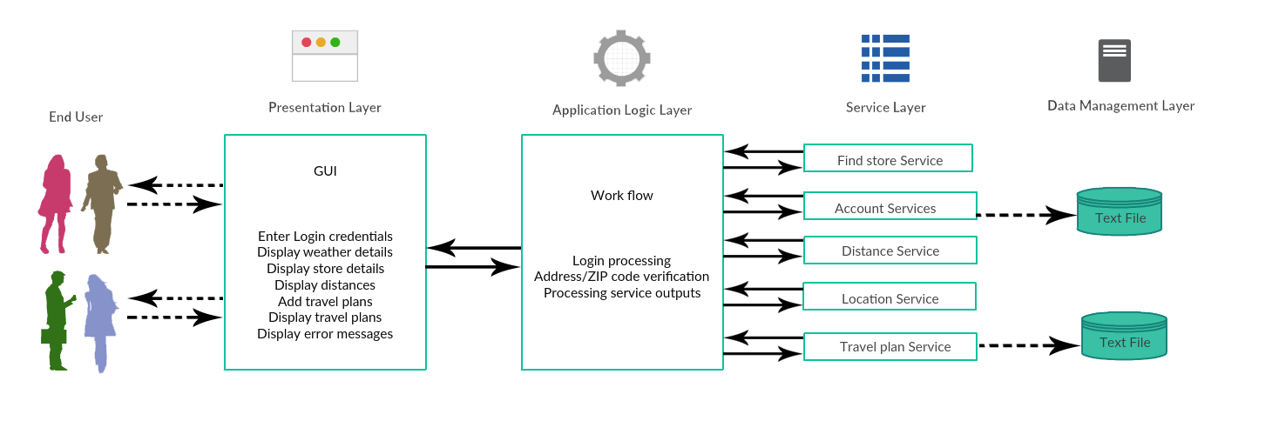**Overall System Design**
2. **Service Directory**

|  |  |  |  |  |
| --- | --- | --- | --- | --- |
| This project is developed by: Harith Neralla | | | | |
| Provider Name | Service name, with input and output types | TryIt link | Service Description | Planned resources needed to implement the service |
| Harith Neralla | *findStore(…)  Input: zipcode and storeName  Output: string | N/A | Finds location of the storeName in the ZIP code. Provides store rating and address. | Google Places API;  JSON.Net |
| Harith Neralla | *getLocationDetails(…)  Input: string (zipcode)  Output: array of string | N/A | Uses existing API to find the weather and location details for the entered ZIP code. | Use API and existing services from Weather Channel;  JSON.Net |
| Harith Neralla | findDistance(…)  Input: current and destination address  Output: array of string | N/A | Use existing API to find the distance between two locations. Will provide best route and link to external map service. | Google Maps API  JSON.Net |
| Harith Neralla | createAccount(…)  Input: string (username/pwd)  Output: string (confirmation) | N/A | Allow users to sign up with a username and password. | Use library functions and database to store credentials. |
| Harith Neralla | addTravelPlan(…)  Input: string (current location, destination, date) | N/A | Allow users to add travel plans to their accounts. | Use library functions and database to store the travel plans |

* = service has been implemented

TryIt links are not available yet because none of the services have been deployed on WebStrar (will be done in Part 2)